From the committee
What are we working on as a committee? An overview:

The autumn meeting 2016
This will take place on Saturday 19 November next, this year in Antwerp; the lovely city along the Schelde! Hosts of the day are Mia and Herman van Hemeldonck (De Groene Swaen, Trintella 44), Nancy and Herman Naegels (Beta Leonis, Trintella V), and Sigrid and Gustav Coppens (Blue Heron, Contessa 32). The latter couple have taken on the task of executive project leaders. They have managed to determine an interesting program for members of all ages, for reasonable prices. We will tell you more about it in this edition of the magazine.

The spring meeting 2017
Next year, the spring meeting will take place in the north, this time in Lelystad; more specifically the Bavariahaven on the Markermeer. It has been over 10 years ago since we were last moored in Lelystad and time has not stood still there. The Ascension weekend is late in the year; from 25 till 28 May.
We want to make the spring meeting more about the younger members. Commission member spring meetings Ben Verhaaf is looking for volunteers to make it -also for the younger members - a convivial and interesting meeting.

Giving more meaning to maintenance
During the annual members’ meeting two years ago, we decided -besides meeting and having a great time- to focus on maintaining the Trintel and Trintella fleet. Committee member Maintenance Willem de Graaf will tell us the latest news further along in this magazine.

Growth of the association
The number of members is growing steadily. As of now we have a total of 222 members. Many new members are owners of the classics, so we suspect that our larger focus on maintenance of the fleet has had a positive result for interest in the association.

The Trintella Friends’ Association new members’ leaflet
The new members’ leaflets have already found their way to many new Trintellas all over the world. We have gone through the first 2500 prints and have ordered a whole new stock. A new set can be easily ordered via our secretary: p.vanderwaa@trintella.org

Schedule of resignation
According to the planning, one committee member and to commission members will resign this year.
All are available for re-election for a new term of three years:
- Frans Robbe is a member of the cash commission of the annual members’ meeting (ALV) and will present himself for re-election during the next annual members’ meeting.
- Peter van der Waa will resign as statutory committee member (secretary) and will be up for re-election during the next annual members’ meeting.
- Frans Slikkerveer will resign as commission member competitions and has been reappointed for the competitions in the south by the committee. We are looking for a successor for the competitions in the north.

The magazine and newsletter
Besides the biannual editions of the magazine, we have started sending a regular newsletter digitally. The newsletter holds current information about various topics. We are working on trying to lower the printing and shipping fees of the magazine. We are also contemplating the future of the magazine.

The website
The platform on which the website is located has been set for the future, which means it will be able to continue for the next couple of years. We are also working on the renewal of the layout and content of the website. A lot of attention goes to the maintenance part in the rubric on Ships and Maintenance, more attention to adventures of our members in the rubric on Travel stories, a separate rubric for events, a clear and approachable presentation of products in the Trintella Friends’ shop, and - behind the log in button - the Friend book.
Jeroen Noot (Vrouwe Cornelia, Trintella Ia) is a great help during all these changes. We will be purchasing support for the regular technical control of the website from outside of the association.

From picture book to friend book
The Friend book has been -behind the log in button- activated on the website! You have to log in to the closed off, protected part of the website to see it and be able to change your profile. If you have forgotten your login and/or password you can easily request it by sending an email to webmaster@trintella.org. We informed you on how to log in and use it in the August/September newsletter. Most pictures of the members who had a profile in the picture book have already been transported to the friend book. We invite you to take a look on your profile to see if your pictures are still up-to-date.

The Trintella Friends’ shop
Every year we add new products to our assortment and take out products that are not doing very well (anymore). This is going very well: it contributed to a larger profit on events. The amount of orders coming in via the website is still growing slowly.

The main Trintella-book
The sale of the Trintella book keeps going steadily. It has continued to amaze us that many of our members do not yet have a jubilee book in their possession! Should you have any intentions to purchase the book, we recommend you do not wait for much longer. The bottom of the book shelf is fast approaching. Ordering can easily be done via the explanations in the Trintella Friends’ shop.

Profile drawings of boat types
The profile drawings of a number of boat types will be added to the assortment of the Trintella Friends’ shop this year. The types concerned are: all classics, the Trintella III and the IIIa, the 38 and 42. The V, the 44, and the 49A are being worked on. The drawings are done on A4 paper and have been framed. 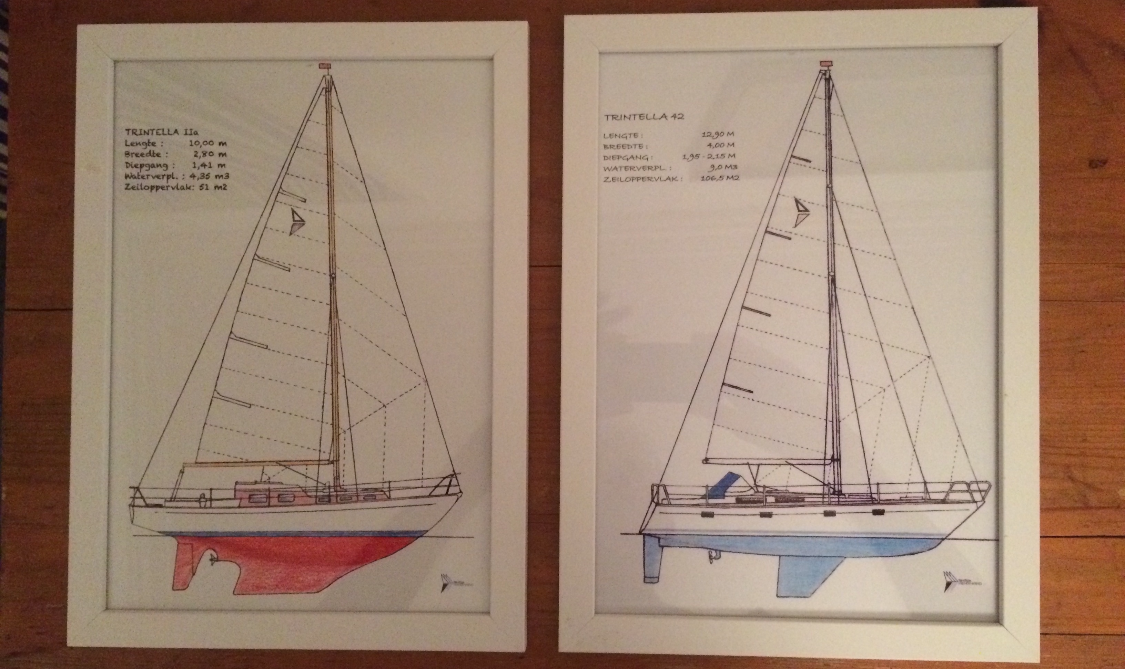
The plan is to have such a drawing of all boat types eventually.

Jubilee year 2018
The Trintella Friends’ Association is going to be celebrating its 50th anniversary in 2018! If that is not a good reason to celebrate, we do not know what is?! The committee is considering how and what to do and would naturally like to involve the members in this decision. This is to be continued in the next newsletters.

The Trintella Friends’ Association’s Christmas card 2016
Commission member PR Sigrid Coppens has a request to all members again this year: Send in your best photo(s) that depict the topic: “Trintella in Winter.” Please send it in JPEG file, file size around approximately 3MB. We will be using the most wonderful photo for the Christmas card again. Please send in your photos before 1 November to s.coppens@trintella.org.

The committee

From the Chairman

The end of my sailing season is fast approaching. You would not say that it is because as I am writing this -halfway through September- tropical temperatures have been forecast! Hopefully the boat will not have to go into winter storage in the beginning of October while it is still wonderfully warm sailing weather?!
Last time I told you about the decaying Ia and the contact I had -in my role as serial coordinator Classics- with the owners Alain and Muriël. The cause of the decay was due to serious misfortune in life. But the plan to restore the boat back to its original self was there. As soon as he wanted to start the job, he would call me to help so we were able to meet and see how the Trintella Friends’ Association could help. I had not yet heard anything so I called them myself to ask how they were doing and how the job was going.
Well.. For all sorts of different reasons, they had not been able to start the job yet. Some weeks ago, he had gone to see since a long time and was shocked at the state of the boat. He made up his mind right there and then to sell her, perhaps to a ‘benign amateur’ who would be willing to restore her.
We agreed that if it does not work, he would call me. Who knows, perhaps we could help as an Association to give her a new life.
To be continued…
In this edition of the newsletter we will catch you up to more successful stories of repairs. Naturally we will also discuss different topics that have been keeping us busy as an association, one of which are the preparations of the autumn meeting in lovely Antwerp.
I hope to see you all there to catch up!

Loet Geldhoff

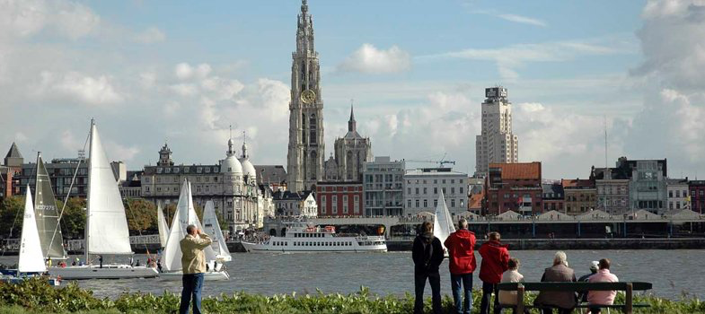

The autumn meeting is in Antwerp this year!

As most of you know, we always organize a spring meeting at the start of the sailing season on the water. This is where we tell each other about our winter maintenance and upcoming sailing plans that summer. At the end of the sailing season we organize the autumn meeting on dry land, where we can catch up on each other’s adventures and other nautical experiences during the past summer months. We will also then have the Annual Members’ Meeting.
This year the autumn meeting is in Antwerp, a lovely city on the Schelde, known for her atmospheric shopping streets, Burgundian lifestyle and amazing historical city center. A city in constant development, but has a constant history of shipping, which has economically been very important for Flanders and guests from all over the world who have been coming to this city to work, to trade, for spending holidays, or for fun for centuries.
This is the place we will have our autumn meeting Saturday 19 November next! Hosts for the day are Mia and Herman van Hemeldonck (De Groene Swaen, Trintella 44), Nancy and Herman Naegels (Beta Leonis, Trintella V), and Sigrid Coppens with Gustaaf Bergé (Blue Heron, Contessa 32). The latter whom have taken on the task of executive project managers. They were successful in sorting out an interesting program for all ages, against reasonable costs:
- We will be welcomed in the hallway of the Van der Valk Hotel from 9:00. This is where we will discuss the practicalities of the day.
- We will take the bus to the Red Star Line Museum in the Montevideostraat at 10:15. We will arrive at approximately 11:00 in the museum after a city tour.
- We will have an hour and a half, from 11:00 till 12:30, to see and experience the remarkable history of the Red Star Line.
- We will walk to restaurant De Groote Witte Arend in the Reyndersstraat at 12:30. It is about a 20 minute walk so we have arranged for transport for the members who cannot walk this far.
- A wonderful Burgundian lunch will await us at 13:00.
- After lunch, at 14:45, we will walk to the Groenplaats, where a tourist tram will take us around to the most wonderful treasures Antwerp has to offer.
- The tram takes us back to Groenplaats at approximately 16:30. We will walk back to the bus from there. The bus will wait for us to take us back to Hotel van der Valk.
- We will arrive back at the hotel at17:00 and will have time to relax and get spruced up.
- We will have drinks at 18:00 and start the Annual Members’ Meeting.
- No later than 19:00 we will be able to enjoy a truly Belgian buffet dinner.
We have managed to keep the costs of participation to the program to €65 per person.
For the members who wish to spend the night in the hotel, we have opted for a number of double rooms. The cost of these (standard) rooms are €75 per room, including breakfast, excluding tourist tax. Parking on the hotel parking lot is free of charge. To make your reservation:
Hotel Van der Valk, Luitenant Lippenslaan 66, 2140 Antwerp (B). Telephone 0032(0)3 235 91 91. Email: reservations@antwerpen.valk.com Book your reservation with the message: lidmaatschap Trintella Vrienden Kring (=Membership Trintella Friends’ Association).
The hotel offers great possibilities to have dinner together for members arriving on Friday 18 November if they wish to dine together.
On behalf of Mia, Herman, Nancy, Herman, Sigrid and Gustaaf we would like to see you and welcome you there!

The committee

Invitation and agenda of the Annual Members’ Meeting 2016

The committee would like to invite all members to join us during the Annual Members’ Meeting on Saturday 19 November at 18:00 in Hotel van der Valk, Luitenant Lippenslaan 66, 2140 Antwerp, Belgium.

The committee suggests the following agenda:
- Opening of the meeting, determining the agenda
- Sent in information and announcements
- Notes of the meeting on 21 November 2015 (see website Trintella Friends’ Association)
- Annual report association year 2015/2016 (see website Trintella Friends’ Association)
- Financial year report association year 2015/2016 (see website Trintella Friends’ Association)
- Results of the cash commission. Request exemption from the committee.
- Schedule of resigning members
  - Frans Robbe will resign as member of the cash commission of the Annual Members’ Meeting and is up for re-election. The committee requests that any other candidates make themselves known to our secretary.
  - Peter van der Waa will resign as statutory committee member (secretary) and is up for re-election. The committee requests that any other candidates make themselves known to our secretary.
7.2 Frans Slikkerveer will resign as commission member competitions for the competitions in the south. The committee has reappointed him. This means we are looking for a volunteer who would like to organize and guide the competitions in the north.
- Activities in the next association year 2016/2017
  - Spring meeting 2017. It is late, from 25 till 28 May. This time in Lelystad, in the Bataviahaven on the Markermeer.
  - Autumn meeting 2017. We suggest to have this on Saturday 18 November in Amersfoort.
  - The 50th anniversary of the Association in 2018
  - Further developments of the maintenance function of the Association.
  - Jubilee book Trintella Yachts: Current status
  - Website Trintella.org
  - Magazine and Newsletter
  - The Trintella Friends’ shop
  - Number of members, New members’ leaflet and the picture book
8.10 Determining contribution fees 2016/2017
9. Estimated budget Association year 2016/2017
- Federation PolyClassics: Current status, activities 2017.
- Questions and closing.

Enrollment form Trintella Friends’ Association autumn meeting on Saturday 19 November 2016 in Antwerp.

Signed,

Name: ......................................................................................................................................................................
Address: ..................................................................................................................................................................
Post code and city: ……………………………………………………………………………………………….
Country: .................................................................................................................................................................
Telephone number: ………………………………………………………………………………………………..
Email address: …………………………………………………………………………………………………….

will take part in the Trintella Friends’ Association’s autumn meeting 2016:
- with …….. adults and …….. children aged 13 or up for €65,- per person.
- with ….... children until age 12. They will be paid for by the Trintella Friends’ Association.

Diet
- For the lunch in the Groote Witte Arend: ……………..…..……………………………………………...
- For the dinner in Restaurant Van der Valk: ………………………………………….......................

Payment (please tick the correct box)
- I hereby grant the Trintella Friends’ Association permission to withdraw the amount of € ………… once from my bank account number ………………..………………………………., name. ………………………………………………………..………., in ……………………….………………………………
- I will transfer the total amount of € .…………. before12 November 2016 to the Trintella Friends’ Association bank account NL10 RABO 0148150594 BIC/Swift: RABONL2U.

Undersigned agrees to the fact that participation is at one’s own risk and will not hold the Trintella Friends’ Association responsible for any injuries sustained during the event, however it has come about.

Signature: ……..……………………………………… Date: …….. - ……… - 2016

